Luke Munro
Learning with Large Datasets
- Datasets commonly > 100,000,000
- Analyze Data
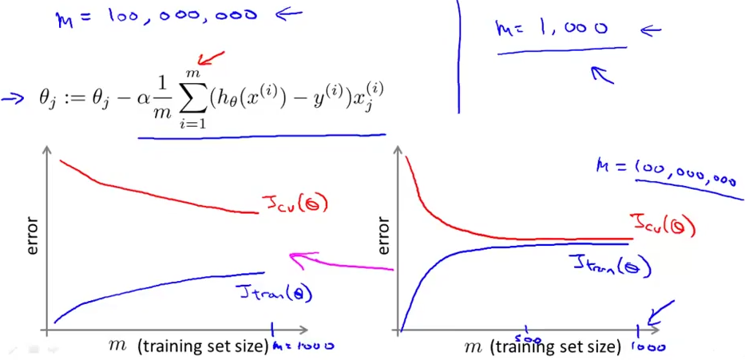
- Stochastic Gradient Descent
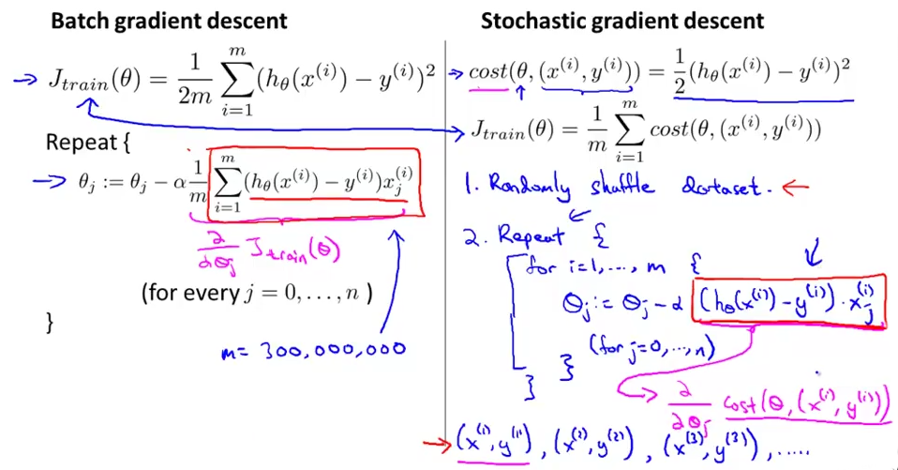

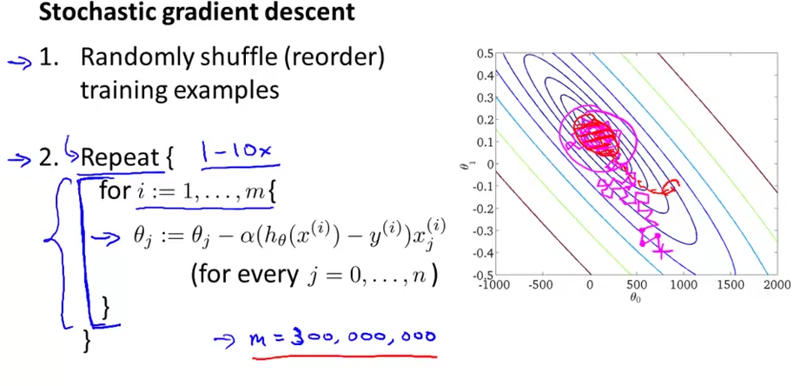
- Mini-batch Gradient Descent
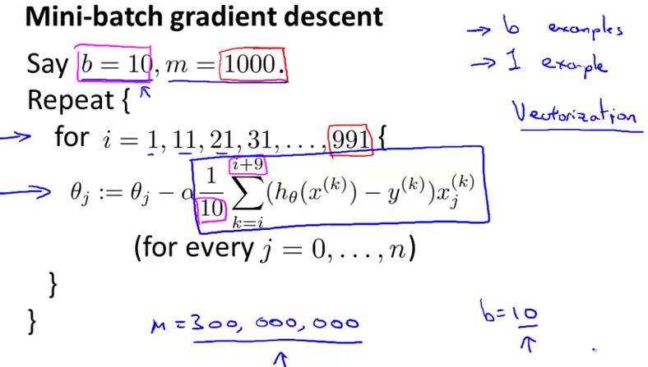

- Stochastic Gradient Descent Convergence
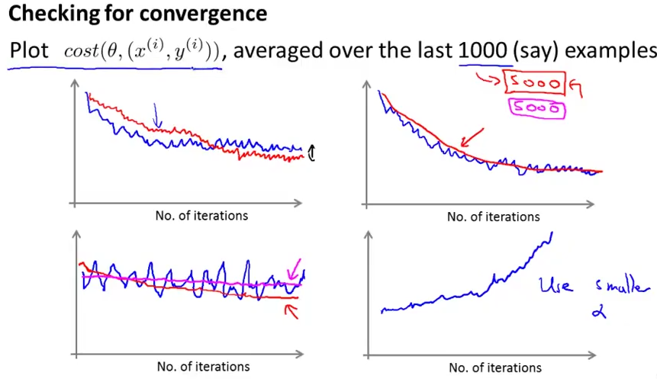
  - Decrease alpha slowly to reach global min
- Online Learning
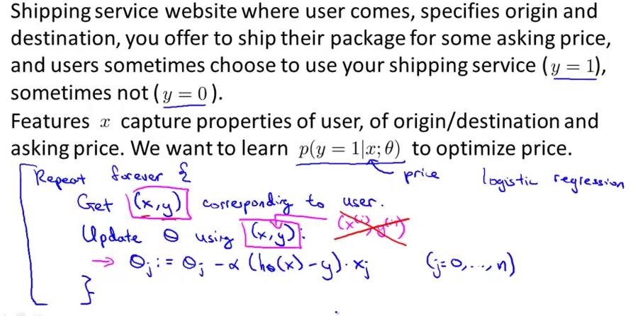
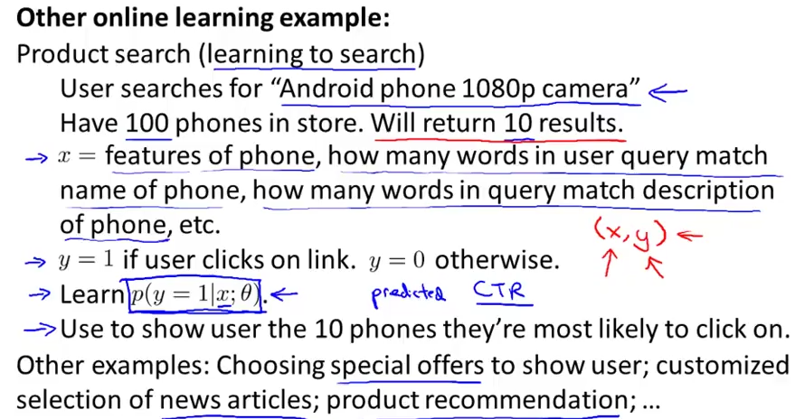
  - Continuous stream of data
  - Can adapt to changing user preferences
- Map Reduce and Data Parallelism
  - Split calculations over machines
  - Or same machine with different cores
